
The Islamia University of
Bahawalpur

Online Job Portal

A project presented to
Department of Computer Science, IUB Bahawalpur

In partial fulfillment of the requirement for the degree of
Bachelor of Information Technology

By

Ali Hassan
F24BINFT7M04024
Session Spring/Fall 2024 - 2026

DECLARATION
I hereby declare that this website and report have not been copied from any source. It is further declared that I have developed this website and prepared the accompanying report based on my own effort, learning, and project work. If any part of this project is proved to be copied or reproduced from another source, I will stand by the consequences. No portion of the work presented has been submitted for any other degree or qualification of this or any other university or institute of learning.
Student Name
Ali Hassan

CERTIFICATE OF APPROVAL
It is to certify that the final year project of BS (Computer Science) titled "Online Job Portal" was developed by Ali Hassan, Roll No. F24BINFT7M04024, Session 2024-2026 under the supervision of Mam Kainat and that, in the supervisor's opinion, it is fully adequate in scope and quality for the degree of Bachelor of Science in Computer Science.

Supervisor

SUPERVISOR NAME
.-----------------------------------

External Examiner
-----------------------------------

Chairperson Department of Computer Science
-----------------------------------

Acknowledgement
First of all, I am thankful to Allah Almighty for giving me the knowledge, strength, patience, and courage to complete this final year project successfully. I am also grateful to my supervisor for continuous guidance, support, and valuable suggestions throughout the project. I would also like to thank my teachers, friends, and family members for their encouragement and help during the development and documentation phases of this project. This project has improved my practical understanding of web development, database design, requirements analysis, system design, and software testing.

YOUR NAME
Ali Hassan

Abbreviations
Abbreviation | Meaning
SRS | Software Requirements Specification
SDD | Software Design Description
HTML | HyperText Markup Language
CSS | Cascading Style Sheets
PHP | Hypertext Preprocessor
SQL | Structured Query Language
MySQL | Relational database management system
XAMPP | Apache, MySQL, PHP, and Perl local server package
GUI | Graphical User Interface
IUB | The Islamia University of Bahawalpur
UML | Unified Modeling Language
API | Application Programming Interface

1 Introduction 6
1.1 Brief 7
1.2 Relevance to Course Modules 7
1.3 Project Background 7
1.4 Related Material and Literature 7
1.5 Analysis from Literature Review (in the context of your project) 8
1.6 Methodology and Software Lifecycle for This Project 8
1.6.1 Rationale behind Selected Methodology 8
2 Problem Definition 9
2.1 Problem Statement 9
2.2 Deliverables and Development Requirements 9
2.3 Current System 10
3 Requirement Analysis 10
3.2 Functional Requirements 13
3.3 Non-Functional Requirements 14
4 Design and Architecture 15
4.1 System Architecture 15
4.2 Data Representation 16
4.3 Process Flow/Representation 16
4.4 Design Models 18
5 Implementation 20
5.1 Important Flow Control / Pseudo Code 20
5.2 Components, Libraries, Web Services and Stubs 20
5.3 Deployment Environment 21
5.4 Tools and Techniques 21
5.5 Best Practices / Coding Standards 21
5.6 Version Control 21
5.7 User Interface 21
6 Testing and Evaluation 23
6.1 Manual Testing 23
6.1.1 System Testing 23
6.1.2 Unit Testing 23
6.1.3 Functional Testing 23
6.1.4 Integration Testing 24
6.2 Automated Testing 24
7 Conclusion and Future Work 25
7.1 Conclusion 25
7.2 Future Work 25
References 26

1 Introduction
This chapter provides an overview of the Online Job Portal project. It explains the motivation behind the system, the technologies used, the academic relevance of the work, related material, and the selected methodology for development.

1.1 Brief
The Online Job Portal is a web-based application designed to connect job seekers with employers through a centralized online platform. The system allows job seekers to register, create profiles, search for suitable jobs, upload resumes, and apply for vacancies. Employers can register, post job openings, view applications, and manage hiring-related activities. An administrator can monitor users, jobs, complaints, and platform settings.
The project was developed using PHP for server-side scripting, MySQL for database management, and HTML, CSS, and JavaScript for the front-end interface. Visual Studio Code was used as the development environment, while XAMPP provided the local Apache and MySQL server for testing and deployment.

1.2 Relevance to Course Modules
- Web Design and Development: development of responsive web pages, forms, menus, and user interfaces.
- Web Systems and Technologies: implementation of a dynamic web-based recruitment platform.
- Database Systems: design and management of MySQL tables for users, jobs, applications, and records.
- Software Engineering: requirement analysis, SRS, SDD, testing, and project documentation.
- Programming Fundamentals and PHP/MySQL: server-side logic, CRUD operations, authentication, and data processing.

1.3 Project Background
Traditional job searching methods, such as newspaper advertisements, walk-in applications, and personal references, are slow, limited, and difficult to manage. Employers also face problems in reaching a large pool of candidates and handling paper-based applications. With the growth of internet access, online recruitment platforms have become a practical solution for connecting talent with opportunities.
This project was developed to simplify and modernize the recruitment process. The system provides job seekers with an easy way to find and apply for jobs, while employers can publish vacancies and review candidates in an organized manner. The project is inspired by existing job portals but is designed in a simpler form suitable for academic demonstration and small-scale use.

1.4 Related Material and Literature
Existing platforms such as LinkedIn, Indeed, and other job portals show that online recruitment systems usually require user registration, job posting, search filters, resume management, and secure communication. Literature and market trends also emphasize user-friendly interfaces, trust, job authenticity, personalization, and efficient search mechanisms.
- User-friendly navigation is important for both job seekers and employers.
- Search and filtering options improve the job matching process.
- Resume upload and profile management help candidates present their skills.
- Admin monitoring improves reliability, security, and platform control.
- Future systems can use advanced features such as resume parsing and AI-based job matching.

1.5 Analysis from Literature Review (in the context of your project)
Commercial job portals often include many advanced features, but such systems may be complex for new users. This project focuses on simplicity, clear navigation, and the core features required for a functional job portal. The system implements essential requirements such as registration, login, job posting, job search, resume management, and job application. It can later be expanded with advanced functions when needed.

1.6 Methodology and Software Lifecycle for This Project
Agile methodology was selected for this project because web applications often require continuous changes, feedback, and improvements. Agile supports short development cycles in which the project can be planned, designed, developed, tested, and improved step by step.
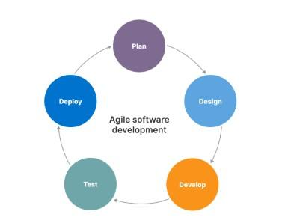
Figure 1.1: Agile software development lifecycle

1.6.1 Rationale behind Selected Methodology
Agile methodology is suitable for the Online Job Portal because the requirements of job seekers and employers can change over time. It allows flexible development, regular testing, and continuous improvement. The methodology also reduces risk because each major feature can be developed and tested independently before integrating it into the complete system.
- Flexibility to add or modify features such as job filters, application tracking, and profile management.
- User-centered development based on feedback from job seekers and employers.
- Frequent testing during each iteration to improve quality and reduce errors.
- Faster delivery of working modules such as registration, login, job posting, and search.

2 Problem Definition
This chapter describes the problem addressed by the Online Job Portal and identifies the expected deliverables, development requirements, and current recruitment limitations.

2.1 Problem Statement
Job seekers and employers often face difficulties in finding and communicating with each other through traditional methods. Newspaper advertisements, personal contacts, and physical visits are time-consuming and limited in scope. Many available online systems can also be complex for small businesses and local users. As a result, suitable job opportunities and qualified candidates may be missed.
The goal of this project is to develop a simple web-based Online Job Portal that allows job seekers to register, search, and apply for jobs, enables employers to post vacancies and review applications, and provides an administrator panel to manage platform activity.

2.2 Deliverables and Development Requirements
The key deliverables of the Online Job Portal are listed below.
- A fully functional online job portal website.
- Registration and login modules for job seekers, employers, and admin users.
- Job posting, job searching, and job application features.
- Responsive and user-friendly front-end interface.
- MySQL database for storing user, job, and application records.
- Project documentation including SRS, SDD, implementation, testing, and future work.
Category | Requirement
Frontend Technologies | HTML, CSS, JavaScript
Backend Language | PHP
Database | MySQL
Web Server | XAMPP with Apache and MySQL
Code Editor | Visual Studio Code / Notepad
Browser | Google Chrome, Firefox, or any modern browser
Operating System | Windows 11 or any compatible operating system
Hardware | Intel Core i3 or higher, minimum 4 GB RAM, and 2 GB free storage

2.3 Current System
In the current traditional system, job seekers usually depend on newspapers, direct visits, or personal references. Employers must manually advertise positions and process applications, which increases time, cost, and paperwork. These methods do not provide efficient searching, filtering, tracking, or digital communication. The proposed system replaces these limitations with a centralized online platform.

3 Requirement Analysis
This chapter contains the Software Requirements Specification (SRS) content for the Online Job Portal. It identifies the users of the system, use cases, functional requirements, and non-functional requirements.
3.1 Use Cases Diagram
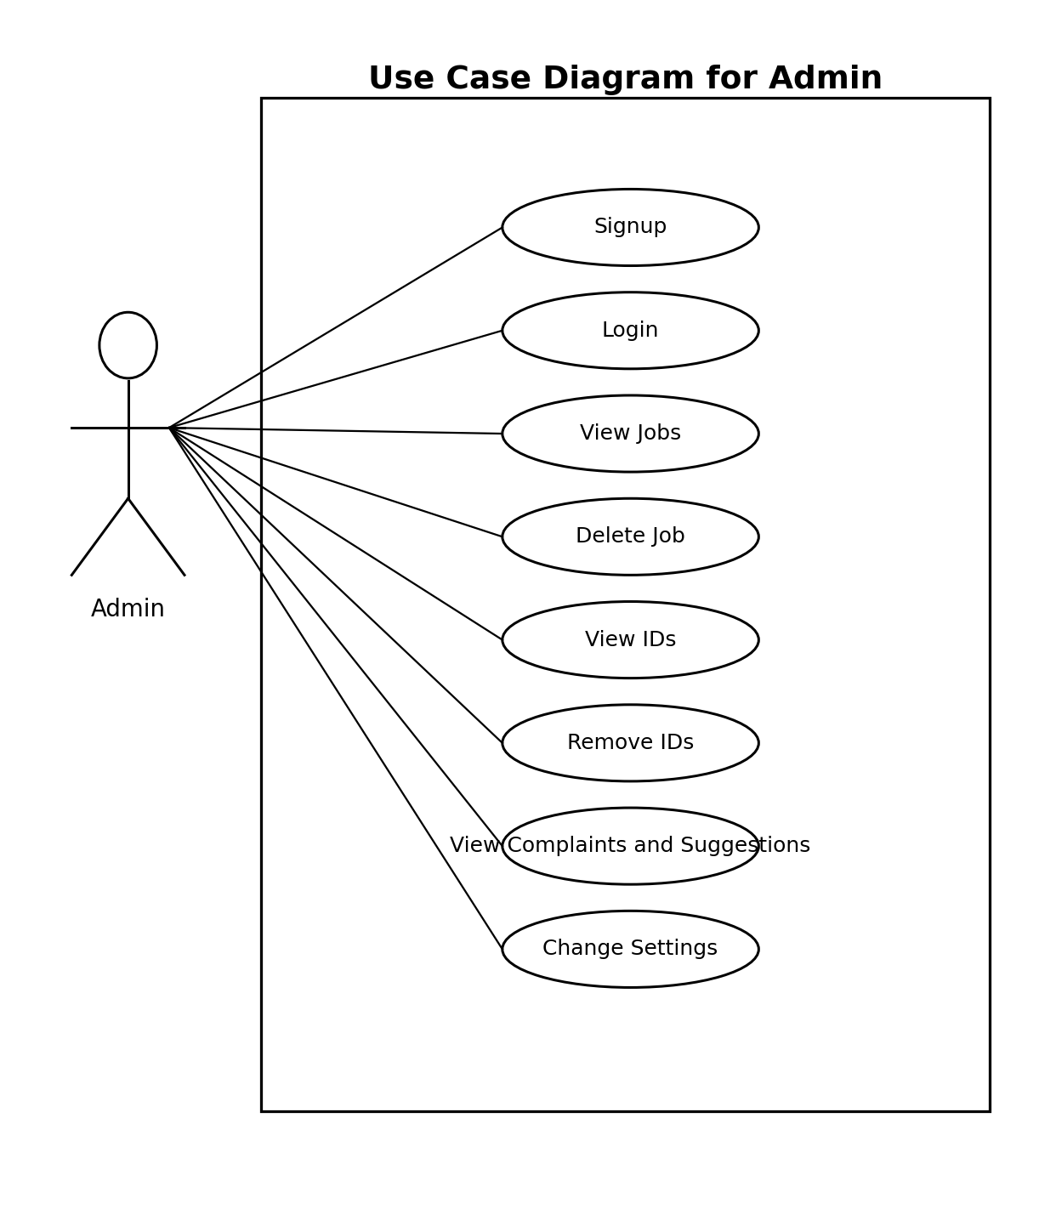
Figure 3.1: Use case diagram for Admin
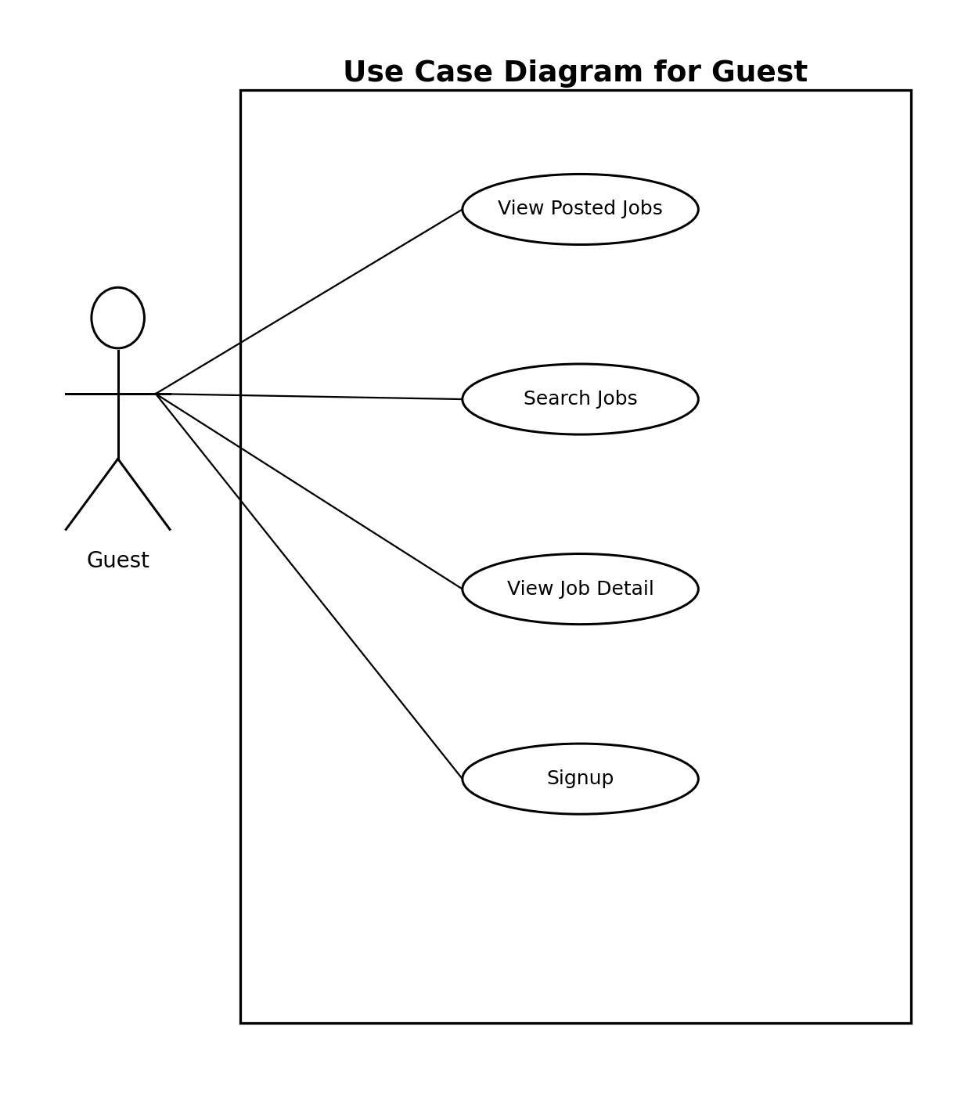
Figure 3.2: Use case diagram for Guest
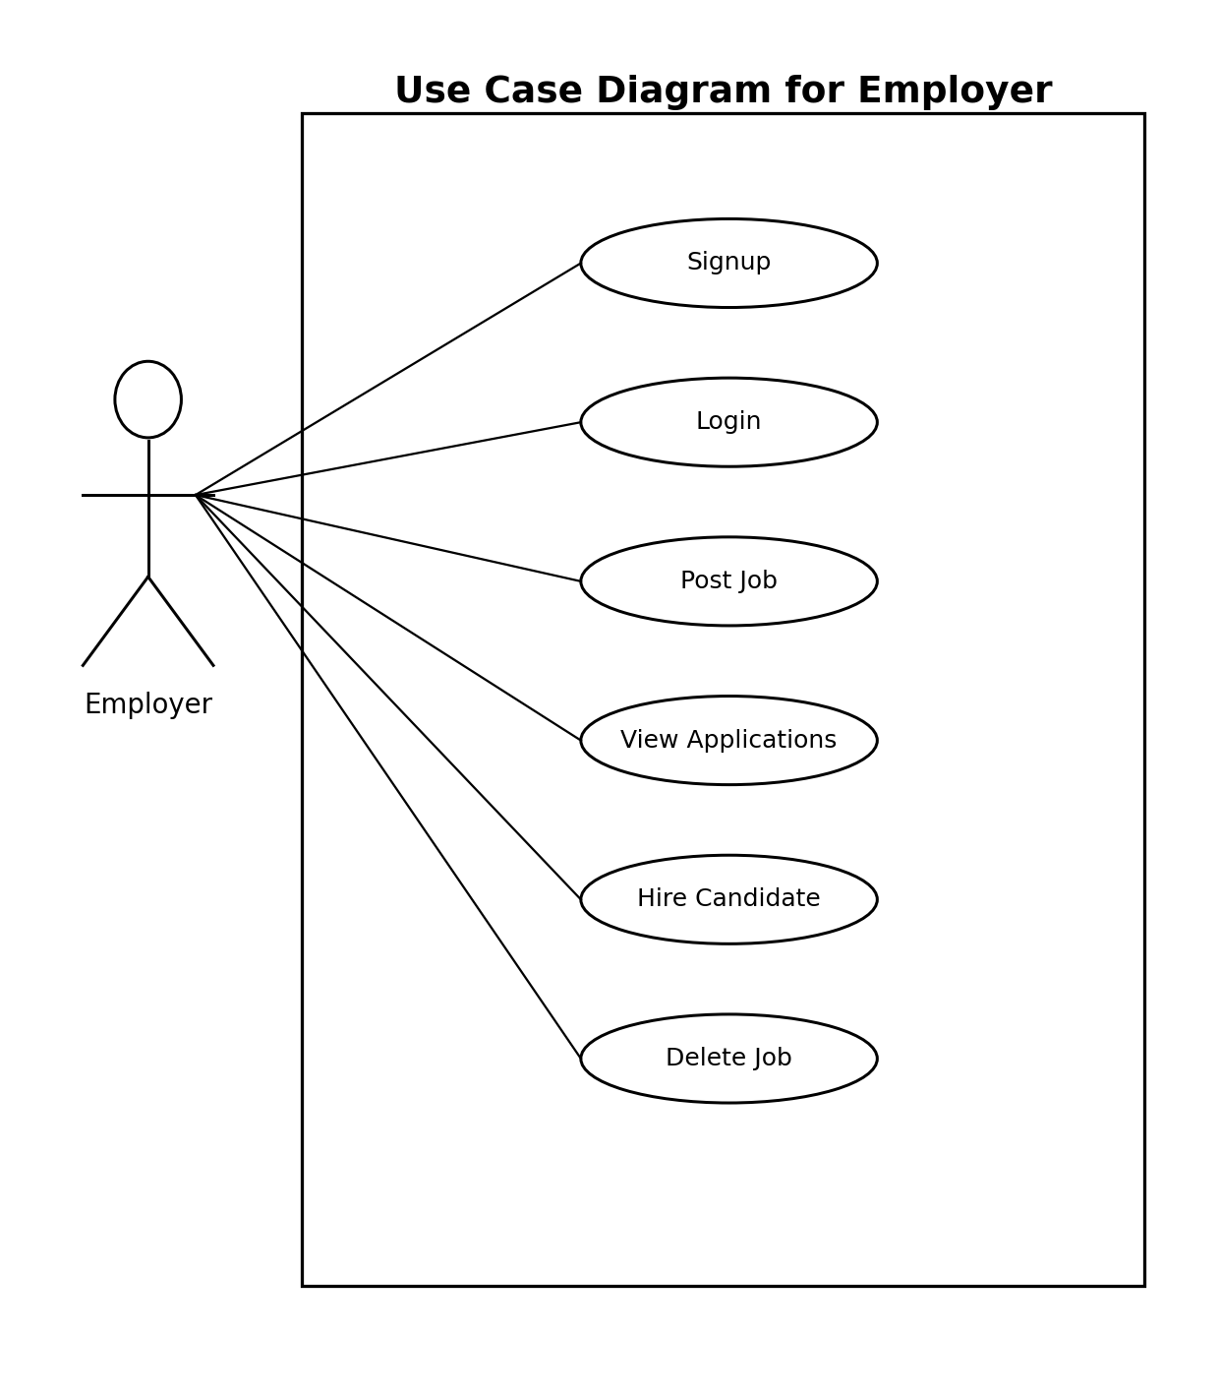
Figure 3.3: Use case diagram for Employer
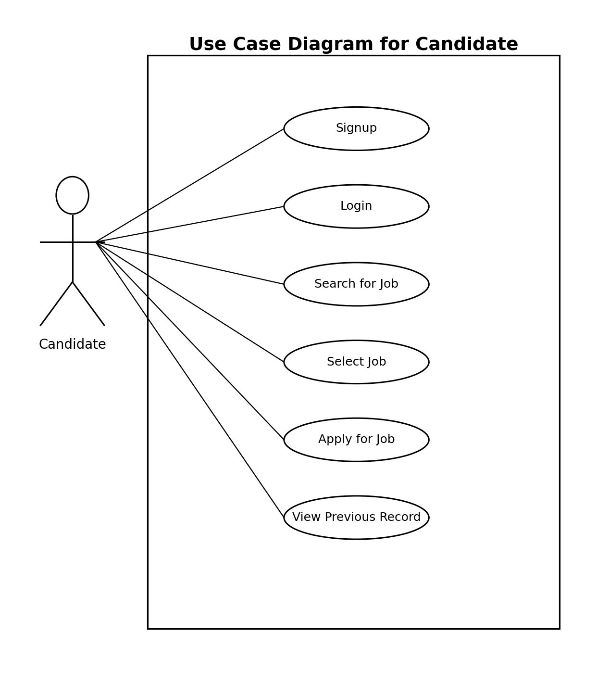
Figure 3.4: Use case diagram for Candidate

3.2 Functional Requirements
Functional requirements describe the services and operations that the system must perform. The major functional requirements of the Online Job Portal are as follows.
ID | Requirement | Description
FR-01 | User Registration | The system shall allow job seekers and employers to create accounts.
FR-02 | User Login/Logout | The system shall authenticate users and allow secure login and logout.
FR-03 | Profile Management | Job seekers shall be able to create, edit, and update their profiles.
FR-04 | Resume Upload | Job seekers shall be able to upload and manage CV or resume files.
FR-05 | Job Search | Users shall be able to search jobs by category, keyword, or related information.
FR-06 | View Job Details | Users shall be able to view complete job details before applying.
FR-07 | Apply for Job | Registered candidates shall be able to apply for selected jobs.
FR-08 | Job Posting | Employers shall be able to create and publish job vacancies.
FR-09 | Application Management | Employers shall be able to view and manage applications received for their jobs.
FR-10 | Admin Management | Admin shall be able to view users, manage jobs, remove records, and view complaints or suggestions.
FR-11 | Category Management | The system shall support management of job categories such as IT, Marketing, Accounting, and others.
FR-12 | Contact/Feedback | Users shall be able to send inquiries, complaints, or suggestions to the administrator.

3.3 Non-Functional Requirements
Category | Requirement
Usability | The interface shall be simple, consistent, and easy to understand for job seekers and employers.
Performance | The system shall load pages and search results within an acceptable time on a normal internet connection.
Reliability | The system shall store user, job, and application data accurately in the database.
Security | The system shall protect login credentials and restrict access based on user role.
Maintainability | The code and database structure shall be organized for future updates and improvements.
Compatibility | The system shall work on modern browsers such as Chrome and Firefox.
Accessibility | The system shall use readable text, clear navigation, and basic accessibility practices.
Scalability | The system shall be extendable for future features such as AI matching, resume parsing, and notifications.

4 Design and Architecture
This chapter contains the Software Design Description (SDD) content for the Online Job Portal. It explains the system architecture, data representation, process flow, and design models used in the project.

4.1 System Architecture
The system follows a web-based client-server architecture. Users access the portal through a browser. The front-end interface communicates with PHP server-side scripts, which process user requests and interact with the MySQL database. The database stores user accounts, job details, applications, categories, and administrative records.
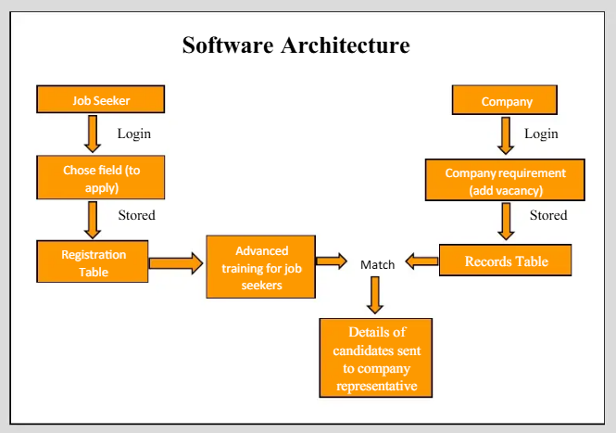
Figure 4.1: Software architecture of Online Job Portal

4.2 Data Representation
The Data Flow Diagram shows how users, employers, and the administrator interact with the job portal. Job seekers send requests to search and apply for jobs. Employers post vacancies and review candidate data. The administrator monitors and manages system records.
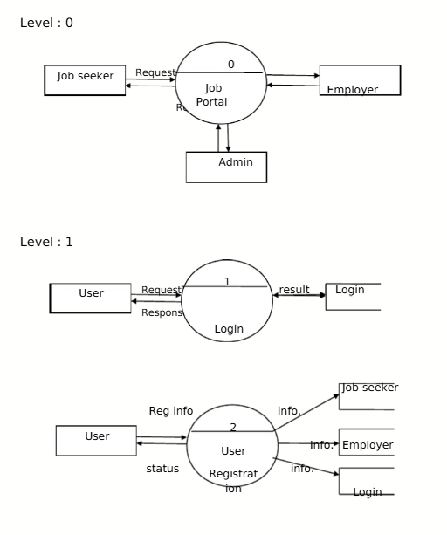
Figure 4.2: Data flow diagram for User and Admin side

4.3 Process Flow/Representation
The activity diagrams represent the working flow of job seekers and employers. A job seeker checks job availability, registers, creates a profile, applies for jobs, and logs out. An employer logs in, uploads a job, searches candidates, selects a suitable candidate, and then logs out.
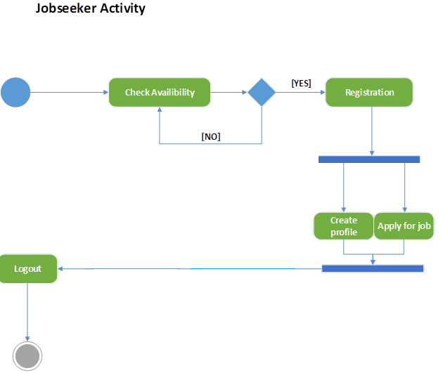
Figure 4.3: Activity diagram for Job Seeker
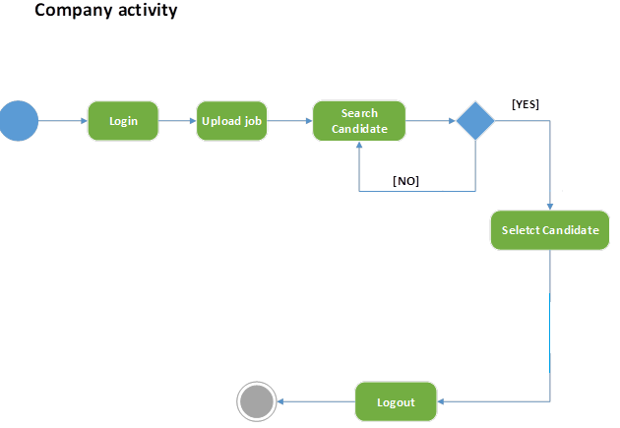
Figure 4.4: Activity diagram for Company/Employer

4.4 Design Models
The design model shows the major classes and entities involved in the system. Important entities include Admin, Company, Jobseeker, Registration, and Job. The relationships show how jobs are managed, posted, searched, and applied for within the portal.
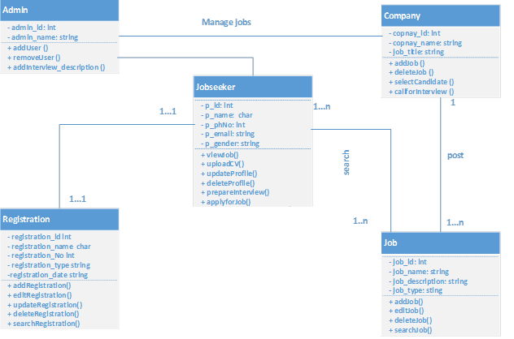
Figure 4.5: Design model / class representation

5 Implementation
This chapter explains the implementation details of the Online Job Portal. It includes flow control, components, deployment environment, tools, coding standards, version control, and user interface details. Source code is not included in this report; only implementation concepts and major modules are described.

5.1 Important Flow Control / Pseudo Code
The following pseudo code describes the major flow of the Online Job Portal.
Module | Pseudo Code / Logic
User Registration | Start -> user enters details -> validate required fields -> check duplicate record -> save data in database -> show success message -> end.
Login | Start -> user enters username/email and password -> validate credentials -> identify role -> redirect to relevant dashboard -> end.
Job Search | Start -> user enters search keyword/category -> query jobs table -> display matching jobs -> user views details -> end.
Apply Job | Start -> candidate logs in -> selects job -> uploads/uses resume -> application saved in database -> confirmation displayed -> end.
Post Job | Start -> employer logs in -> enters job details -> validate job information -> store job record -> display posted job -> end.
Admin Control | Start -> admin logs in -> view users/jobs/complaints -> update or delete selected records -> save changes -> end.

5.2 Components, Libraries, Web Services and Stubs
The project uses standard web development components. PHP scripts handle server-side processing, MySQL manages persistent data storage, HTML and CSS build the structure and design of web pages, and JavaScript supports client-side interaction and validation. XAMPP provides Apache and MySQL services for local execution.
Component | Purpose
HTML | Creates structure of web pages and forms.
CSS | Provides styling, layout, and responsive design.
JavaScript | Adds client-side validation and interactive behavior.
PHP | Processes form data, manages sessions, and communicates with the database.
MySQL | Stores records of users, jobs, applications, and categories.
Apache/XAMPP | Runs the local web server and database environment.

5.3 Deployment Environment
The Online Job Portal can be deployed on a local server using XAMPP or on a web hosting server that supports PHP and MySQL. During development, the project was tested locally on Windows with Apache and MySQL services running through XAMPP.

5.4 Tools and Techniques
- Visual Studio Code / Notepad for coding and editing.
- XAMPP for local server and database environment.
- MySQL database for data storage.
- MS Word for documentation.
- UML diagrams and flow diagrams for system design.

5.5 Best Practices / Coding Standards
- Use meaningful and consistent variable, file, and table names.
- Keep database queries organized and readable.
- Avoid repeated code by reusing common functions where possible.
- Validate user inputs before saving data.
- Organize files and folders according to modules.
- Use comments for important logic and future maintenance.
- Apply role-based access control for admin, employer, and job seeker areas.

5.6 Version Control
Version control helps manage changes in the source code and allows the developer to track updates during the development process. For future improvement, Git or GitHub can be used to maintain project versions, collaborate with team members, and safely restore older versions when needed.

5.7 User Interface
The user interface is designed to be clean and easy to navigate. The home/dashboard page provides quick access to important sections, while the job listing screen displays available job opportunities with details and an apply option.
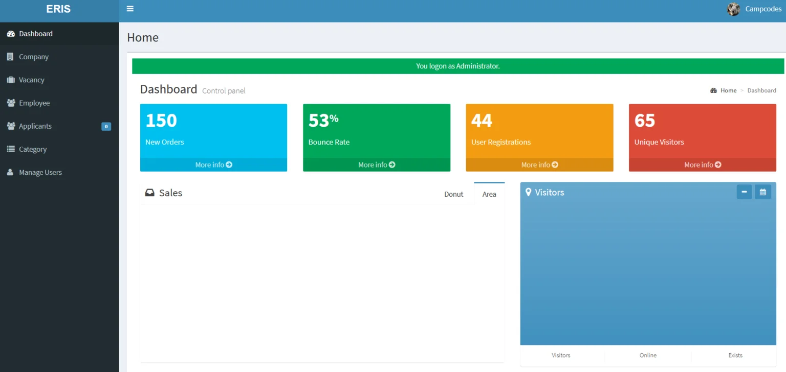
Figure 5.1: Admin dashboard / home page
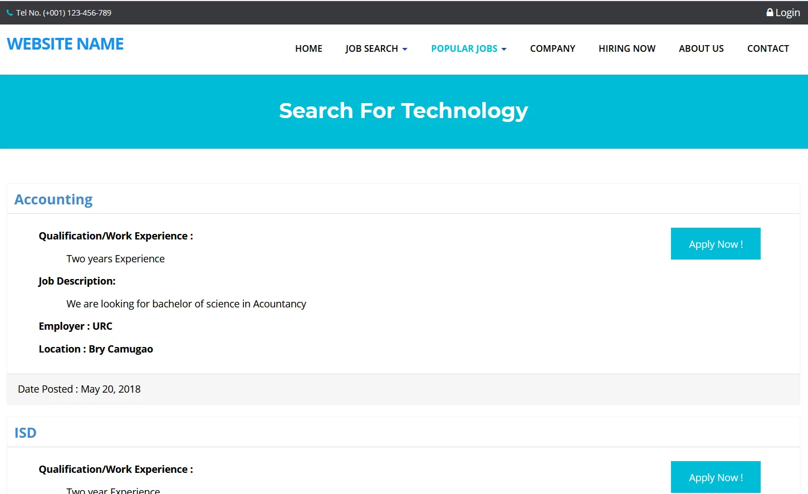
Figure 5.2: Job listing screen

6 Testing and Evaluation
Testing verifies whether the Online Job Portal works according to the stated requirements. The system was evaluated through manual testing, unit testing, functional testing, integration testing, and basic performance observations.

6.1 Manual Testing

6.1.1 System Testing
System testing was performed after integrating the main modules to confirm that registration, login, job search, job posting, job application, and admin management work together correctly.

6.1.2 Unit Testing
No. | Test Case | Input / Attribute | Expected Result | Result
1 | Login as Admin | Valid admin username and password | Admin dashboard opens successfully | Pass
2 | Register as Job Seeker | Valid name, email, password, and profile details | Job seeker account is created | Pass
3 | Register as Employer | Valid company and login details | Employer account is created | Pass
4 | Post a Job | Valid job title, category, description, and requirements | Job is saved and displayed in job listings | Pass
5 | Apply for Job | Candidate selects a job and submits application | Application is stored successfully | Pass

6.1.3 Functional Testing
No. | Functionality | Expected Result | Result
1 | User registration | User account should be created after valid input | Pass
2 | User login | Correct dashboard should open according to user role | Pass
3 | Job search | Matching jobs should be displayed | Pass
4 | Job application | Candidate application should be submitted and stored | Pass
5 | Admin job deletion | Selected job should be removed from the system | Pass
6 | Employer view applications | Employer should see applications for posted jobs | Pass

6.1.4 Integration Testing
No. | Scenario | Expected Result | Result
1 | Job seeker registers, logs in, searches job, and applies | All connected modules work without data loss | Pass
2 | Employer logs in, posts a job, and views applicants | Job and application records are linked correctly | Pass
3 | Admin logs in and manages users/jobs | Admin changes are reflected in the database | Pass
4 | Invalid login attempt | System rejects wrong credentials and shows error | Pass

6.2 Automated Testing
Automated testing can be added in the future to improve quality and reduce manual effort. Basic automated testing may include form validation checks, database connection testing, and module-level tests for PHP scripts.
Tool Name | Tool Description | Applied On | Result
Browser Developer Tools | Used to inspect page errors, network requests, and layout issues | UI pages and JavaScript validation | Successful
PHP Error Reporting | Used to identify PHP syntax and runtime errors | Backend PHP scripts | Successful
MySQL Query Testing | Used to verify insert, update, select, and delete operations | Database queries | Successful
Manual Scripted Checks | Repeated checklist-based test execution | Registration, login, job posting, and application modules | Successful

7 Conclusion and Future Work

7.1 Conclusion
The Online Job Portal project successfully demonstrates how a web-based system can simplify the recruitment process for job seekers and employers. The developed system provides essential features such as registration, login, job posting, job searching, resume management, application submission, and admin control. Through this project, practical knowledge of web development, database design, requirement analysis, system design, and testing was gained.
The project achieved its main objective by creating a centralized platform where candidates can find job opportunities and employers can manage vacancies and applications more efficiently than traditional manual methods.

7.2 Future Work
The system can be improved and expanded in future versions by adding more advanced and intelligent features.
- AI-based job recommendation according to candidate skills and employer requirements.
- Resume parsing to automatically extract education, skills, and experience.
- Email and SMS notifications for job alerts and application status updates.
- Advanced search filters such as salary range, location, experience, and job type.
- Online interview scheduling and employer-candidate messaging.
- Stronger security features such as password hashing, email verification, and two-factor authentication.
- Mobile-friendly progressive web application or Android/iOS app version.
- Analytics dashboard for employers and administrators.

References
1. Pressman, R. S., & Maxim, B. R. (2019). Software Engineering: A Practitioner's Approach. McGraw-Hill.
2. Sommerville, I. (2016). Software Engineering. Pearson Education.
3. W3Schools. HTML, CSS, JavaScript, PHP, and MySQL Tutorials. Accessed for general web development concepts.
4. PHP Manual. Official PHP Documentation. Accessed for server-side scripting concepts.
5. MySQL Documentation. Official MySQL Reference Manual. Accessed for database design and query concepts.
6. Existing job portal platforms such as LinkedIn and Indeed were reviewed for understanding common recruitment portal features.

